**Network Fundamentals Week 7 Log Book**

**Summary**

We installed a new hard drive and RAM to an already working computer

**Implementation**

We carried out the process by first putting on electrostatic wristbands to ground any static electricity we could transfer from our bodies. The circuitry within the computer runs at around 2 volts to 12 volts so static electricity which goes up to 50 volts could easily damage the circuitry. We then took the side panel off the computer, and installed the hardware. The hard drive slotted in underneath the CD drive and was screwed in. We then used the SATA cable and SATA connectors to connect the motherboard and PSU to the hard drive. We then installed the 2 cards of 2.00GB RAM into the empty slots in the motherboard. We also changed the drive name of the new hard drive.

**Results**

Screenshot clearly showing the new amount of installed memory 8.00GB and the extra drive installed on the system.

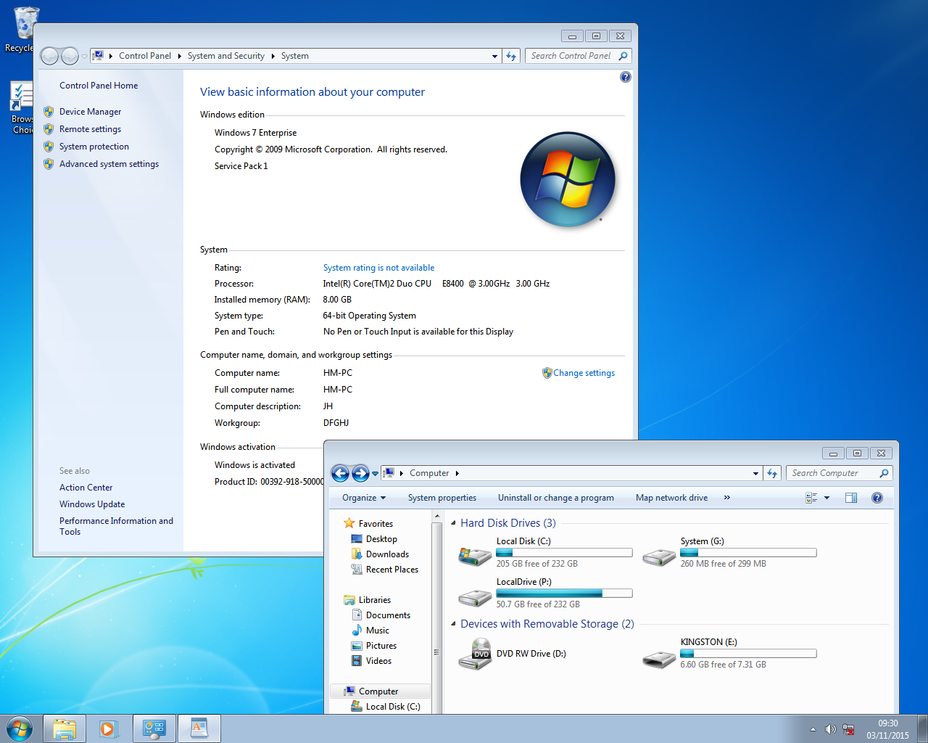

Screen shots showing the computer management utility program and then changing the drive name and then the result of that.

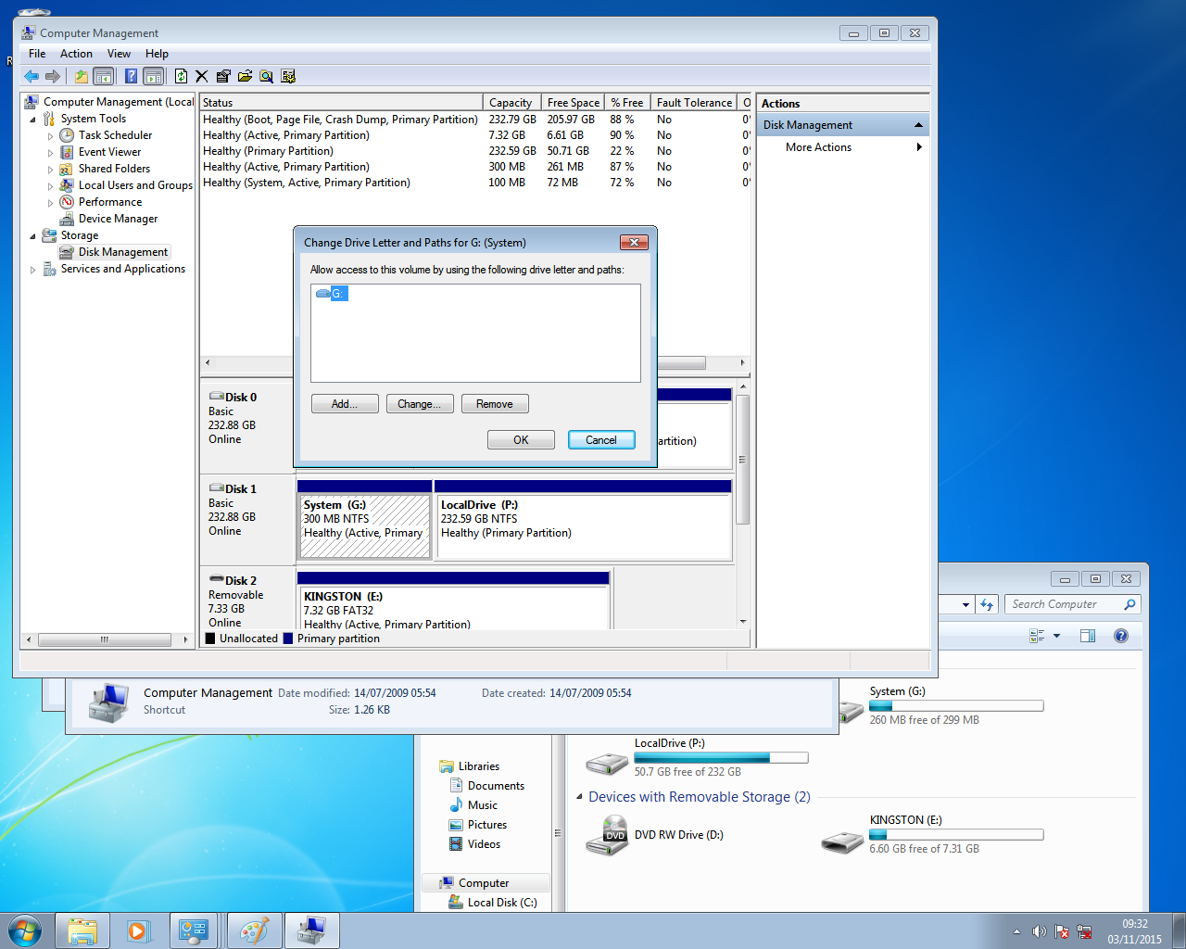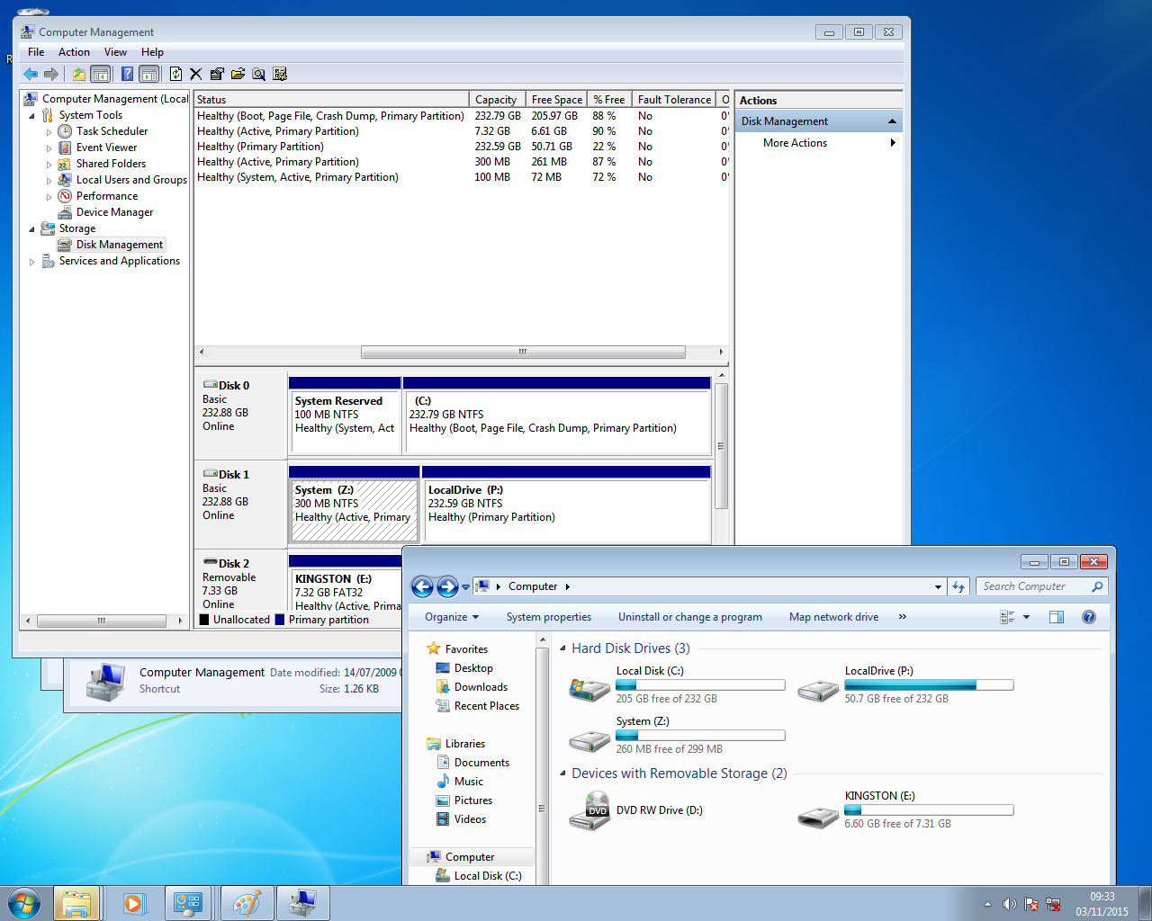

**Conclusion**

You can use Computer Management to change the name of drives on a computer and when installing new hardware into a computer we should use some form of static protection to prevent damage to the circuit boards.